**WEEK 4 – HW**

Q1. Problem 1: Movie Ticket Booking 🎬

Soln.

public class MovieTicketSystem {

static class MovieTicket {

private String movieName;

private String theatreName;

private int seatNumber;

private double price;

public MovieTicket() {

this("Unknown", "Not Assigned", 0, 0.0);

}

public MovieTicket(String movieName) {

this(movieName, "Not Assigned", 0, 200.0);

}

public MovieTicket(String movieName, int seatNumber) {

this(movieName, "PVR", seatNumber, 250.0);

}

public MovieTicket(String movieName, String theatreName, int seatNumber, double price) {

this.movieName = movieName;

this.theatreName = theatreName;

this.seatNumber = seatNumber;

this.price = price;

}

public void printTicket() {

System.out.println("----- Ticket Details -----");

System.out.println("Movie: " + movieName);

System.out.println("Theatre: " + theatreName);

System.out.println("Seat No: " + seatNumber);

System.out.println("Price: Rs." + price);

System.out.println("--------------------------\n");

}

}

public static void main(String[] args) {

MovieTicket t1 = new MovieTicket();

MovieTicket t2 = new MovieTicket("Inception");

MovieTicket t3 = new MovieTicket("Interstellar", 15);

MovieTicket t4 = new MovieTicket("Avengers", "IMAX", 42, 500.0);

t1.printTicket();

t2.printTicket();

t3.printTicket();

t4.printTicket();

}

}

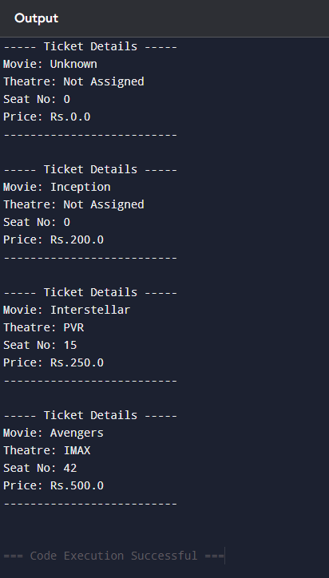

Q2. Bank Account System 💳

Soln.

public class BankAccountSystem {

static class BankAccount {

private String accountHolder;

private int accountNumber;

private double balance;

public BankAccount() {

this("Unknown", (int)(Math.random()*10000), 0.0);

}

public BankAccount(String accountHolder) {

this(accountHolder, (int)(Math.random()*10000), 0.0);

}

public BankAccount(String accountHolder, double initialBalance) {

this(accountHolder, (int)(Math.random()*10000), initialBalance);

}

public BankAccount(String accountHolder, int accountNumber, double balance) {

this.accountHolder = accountHolder;

this.accountNumber = accountNumber;

this.balance = balance;

}

public void deposit(double amount) {

if (amount > 0) balance += amount;

}

public void withdraw(double amount) {

if (amount > 0 && balance >= amount) balance -= amount;

else System.out.println("Insufficient balance for " + accountHolder);

}

public void displayAccount() {

System.out.println("Account Holder: " + accountHolder);

System.out.println("Account Number: " + accountNumber);

System.out.println("Balance: Rs." + balance);

System.out.println("---------------------------");

}

}

public static void main(String[] args) {

BankAccount acc1 = new BankAccount();

BankAccount acc2 = new BankAccount("Alice");

BankAccount acc3 = new BankAccount("Bob", 5000);

acc1.deposit(2000);

acc2.deposit(1500);

acc3.withdraw(2000);

acc1.displayAccount();

acc2.displayAccount();

acc3.displayAccount();

}

}

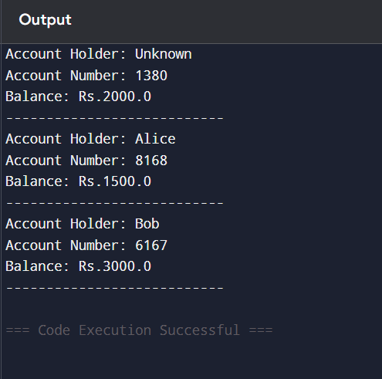

Q3. Library Book Management 📚

Soln.

public class LibrarySystem {

static class Book {

private String title;

private String author;

private String isbn;

private boolean isAvailable;

public Book() {

this("", "", "", true);

}

public Book(String title, String author) {

this(title, author, "", true);

}

public Book(String title, String author, String isbn) {

this(title, author, isbn, true);

}

public Book(String title, String author, String isbn, boolean isAvailable) {

this.title = title;

this.author = author;

this.isbn = isbn;

this.isAvailable = isAvailable;

}

public void borrowBook() {

if (isAvailable) isAvailable = false;

else System.out.println(title + " is already borrowed.");

}

public void returnBook() {

isAvailable = true;

}

public void displayBookInfo() {

System.out.println("Title: " + title);

System.out.println("Author: " + author);

System.out.println("ISBN: " + isbn);

System.out.println("Available: " + isAvailable);

System.out.println("---------------------------");

}

}

public static void main(String[] args) {

Book b1 = new Book();

Book b2 = new Book("1984", "George Orwell");

Book b3 = new Book("The Alchemist", "Paulo Coelho", "12345");

b1.displayBookInfo();

b2.displayBookInfo();

b3.displayBookInfo();

b3.borrowBook();

b3.displayBookInfo();

b3.returnBook();

b3.displayBookInfo();

}

}

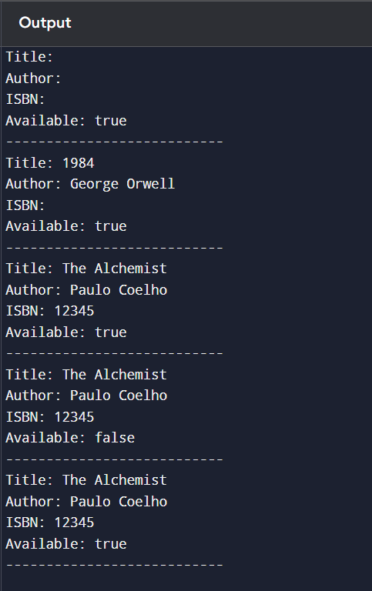

Q4. Food Delivery Order 🍔

Soln.

public class FoodDeliverySystem {

static class FoodOrder {

private String customerName;

private String foodItem;

private int quantity;

private double price;

private static final double FIXED_RATE = 150.0;

public FoodOrder() {

this("Unknown", "Unknown", 0, 0.0);

}

public FoodOrder(String foodItem) {

this("Unknown", foodItem, 1, FIXED_RATE);

}

public FoodOrder(String foodItem, int quantity) {

this("Unknown", foodItem, quantity, quantity * FIXED_RATE);

}

public FoodOrder(String customerName, String foodItem, int quantity, double price) {

this.customerName = customerName;

this.foodItem = foodItem;

this.quantity = quantity;

this.price = price;

}

public void printBill() {

System.out.println("----- Order Bill -----");

System.out.println("Customer: " + customerName);

System.out.println("Food Item: " + foodItem);

System.out.println("Quantity: " + quantity);

System.out.println("Total Price: Rs." + price);

System.out.println("----------------------\n");

}

}

public static void main(String[] args) {

FoodOrder o1 = new FoodOrder();

FoodOrder o2 = new FoodOrder("Burger");

FoodOrder o3 = new FoodOrder("Pizza", 3);

FoodOrder o4 = new FoodOrder("Alice", "Pasta", 2, 400.0);

o1.printBill();

o2.printBill();

o3.printBill();

o4.printBill();

}

}

